Pedigree for Bob x Brie Puppies Date of Birth: May 28, 2020
]
Puppy | 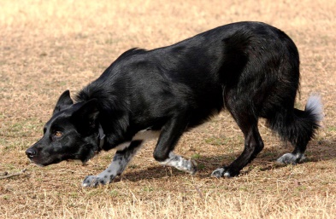  Imp. Bob  ABCA # 435149  Mary Ann Thomas  Bahama, NC  D. Games  Powys, UK | Choc  ISDS # 312120  Mrs. A Grimes  Powys, UK | Craig ISDS #254411  R E Lewis  Clwyd, Wales | ##Star ISDS #211076  S L Davidson, Scotland
Jan ISDS #216729
R E Lewis, Wales
 |  |  | Sweet ISDS #300535  R G Games  Talgarth, UK | Sweep ISDS #277391  P Williams, Wales
Del ISDS #285079
P Williams, Wales
 |  | Tam  ISDS # 312127  D Games  Powys, UK | Dennis ISDS #267666  P N Legge  Hereford, UK | Storm ISDS #236373  W D Reed, Wales
Jill ISDS #229594
P N Legge, UK
 |  |  | Tiny ISDS #303835  D Games  Powys, UK | Jim ISDS #264685  S L Davidson, Scotland
Mel ISDS #287042
D Games, UK
 | 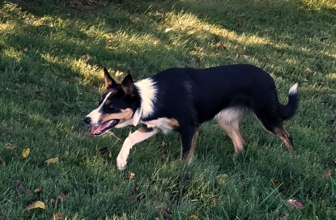  HF Brie  ABCA # 471799  Ginger Bruton  Wilmington, NC  Anita Kim Hagan  Castle Hayne, NC | 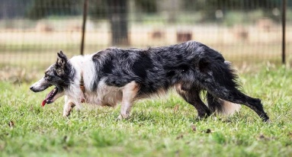  Hard Rock Neal  ABCA # 382509  Bonne Gibbs  Social Circle, GA | Kyle ABCA #361370  Nick Donaldson  Ranger, GA | HardRock Rip ABCA #328692  Chanelle Barron, AK
Kate ABCA #278822
Chanelle Barron, AK
 |  |  | Spice ABCA #360085  Bonnie Gibbs  Social Circle, GA | Dan ABCA #328822  John T Wilson, TX
Tarra ABCA# 295219
John T Wilson, TX
 |  | 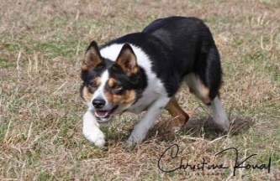  Imp. BAW Lass  ABCA # 449331  W E Van Donden  Haaskbegen, NL | Gary ISDS #308277  S W Van Der Zweep  L D Heteren, NL | Spot ABCA #281596  S Van Der Sweep, NL
Gwen ABCA #281000
L N Watkins, NL
 |  |  | Karven Bracken ISDS #314711  W E Van Donden  Haaskbegen, NL | Spot ISDS #272088  Kevin Evans, Wales
Karven Nell ISDS #302192
R W Lewis, Wales

